# 

# 1. Assignment Requirements

* Very small
* Very cheap
* Very light
* 100% reliable
* Very short development period

Intern conflict between 1,2,3 requirements and reliability. Agreement solution needed.

# 2. Availability (System characteristics)

## 2.1 Maximum system outage time

A satellite in orbit is a **stable** vehicle. The control system can be in error for **several minutes**.

## 2.2 Probability of generating an erroneous output

Mean Time Between Failure: Average time between faults (inverse to fault intensity):



The reliability of a system in an interval of time can be expressed as:



In this case, the mission has a length of **3 years** and it is supposed to have a reliability of 100%. This becomes into a fault intensity of 0, which is almost impossible. Anyway, assuming that possibility, the expenses in software development would increase too much to fulfil the estimated budget. Thus, a compromise between expenses and reliability must be achieved.

Assuming a reliability of **99%**, the probability of a faulty control command in this satellite control system would be about **10^-10**.

## 2.3 Total availability

A spacecraft scientific instrument must be able to measure during at least **99%** of the spacecraft total mission time

# 3. Reliability (Performance characteristics)

Probability of failure-free software operation for a specified period of time in a specified environment

Cross-strap philosophy when duplicate blocks

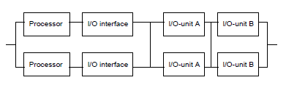

Max reliability (most efficient) = duplicate the parts with the largest fault intensity:

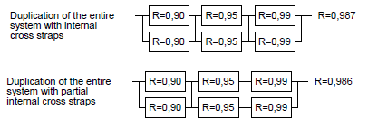

* In parallel: R_total = 2R – R^2
* In series: R_total = R^2

Error detection coverage

The capability of detecting errors in a unit of time. To reach higher the reliability target it is required that the error detection coverage in unit 1 was larger than **99%**, which **clash with the initial requirement of having a very short development period**.

# 4. Cross-strapping points

Identify the Fault Containment Regions (areas where an error affects the function of the block) in the system block diagram

